“ONLINE EXAMINATION AND PROCTORING PLATFORM”
A Project Report Submitted in the partial fulfillment of the requirements for the award of the degree of

BACHELOR OF TECHNOLOGY
In

DEPARTMENT OF COMPUTER SCIENCE ENGINNERING
&
DEPARTMENT OF COMPUTER SCIENCE AND INFORMATION TECHNOLOGY
By

POLISETTY SREEHARSHA 2520030123
ADUNURI BHAVANA SRI 2520030232

Under the Esteemed Guidance of

Dr Ramatenki Sateesh Kumar
Assistant Professor
Department of Computer Science and Engineering




K L (Deemed to be) University DEPARTMENT OF COMPUTER SCIENCE ENGINEERING
&

DEPARTMENT OF COMPUTER SCIENCE AND INFORMATION TECHNOL

Declaration

The Project Report entitled “Online Examination and Proctoring Platform” is a record of Bonafide work of POLISETTY SREEHARSHA - 2520030123 , ADUNURI BHAVANA SRI - 2520030232submitted in partial fulfillment for the award of B. Tech in Computer Science and Engineering (or) Computer Science and Information Technology to the K L University. The results embodied in this report have not been copied from any other departments/University/Institute.

POLISETTY SREEHARSHA – 2520030123
ADUNURI BHAVANA SRI – 2520030232

K L (Deemed to be) University

DEPARTMENT OF COMPUTER SCIENCE ENGINEERING

&

DEPARTMENT OF COMPUTER SCIENCE AND INFORMATION TECHNOLOGY

CERTIFICATE

This is certify that the mini project based report entitled “Online Examination and Proctoring Platform” is a bonafide work done and submitted by POLISETTY SREEHARSHA - 2520030123 , ADUNURI BHAVANA SRI – 2520030232 in partial fulfillment of the requirements for the award of the degree of BACHELOR OF TECHNOLOGY in Department of Computer Science Engineering, K L (Deemed to be University), during the academic year 2026-2027.

Signature of the Guide

Signature of the Course Coordinator Signature of the HOD

ACKNOWLEDGEMENT
The success in this project would not have been possible but for the timely help and guidance rendered by many people. Our wish to express my sincere thanks to all those who has assisted us in one way or the other for the completion of my project.

Our greatest appreciation to my Course Coordinator Dr Ramatenki Sateesh Kumar, and my guide Dr Ramatenki Sateesh Kumar, Department of Computer Science which cannot be expressed in words for his/her tremendous support, encouragement and guidance for this project.

We express our gratitude to Dr. P Venkateshwara Roa (CSE)/Dr. Kaja Shareef (CSIT), Head of the Department for Computer Science Engineering/ Department for Computer Science and Information Technology for providing us with adequate facilities, ways and means by which we are able to complete this project-based Lab.

We thank all the members of teaching and non-teaching staff members, and also who have assisted me directly or indirectly for successful completion of this project. Finally, I sincerely thank my parents, friends and classmates for their kind help and cooperation during my work.

POLISETTY SREEHARSHA – 2520030123
ADUNURI BHAVANA SRI – 2520030232

Abstract

The Online Examination and Proctoring Platform is a web-based application developed to simplify and manage online examinations securely. The platform provides separate interfaces for students and faculty, where faculty can create examinations, manage questions, monitor examination activities, and view results. Students can register, log in, view available examinations, attend scheduled exams, submit answers, and view their results.

The system is developed using React.js and Vite for the frontend, Node.js and Express.js for the backend, and MongoDB with Mongoose for database management. It provides authentication and role-based access for students and faculty. The platform also supports features such as timed examinations, automatic evaluation, question image uploads, and storage of examination data and results.

A major feature of the platform is browser-based proctoring, which monitors the student's camera and examination activities. TensorFlow.js and the COCO-SSD model are used to detect situations such as no person, multiple persons, or a mobile phone during an examination. Activities such as tab switching and leaving full-screen mode are also monitored and stored as proctoring logs. Overall, the platform provides a centralized solution for online examination management, automatic evaluation, and AI-assisted examination monitoring.

Index

S.  No. | Chapters | Topics | Page.no
 |  | Acknowledgement
 |  | Abstract
1 | Introduction | - Background of the project  - Problem statement  - Scope of the project  - Objective(s)  - Importance of the application  - Target users/audience | 5-15
2 | System Requirements | - Hardware requirements  - Software requirements  - Development tools and frameworks | 16-21
3 | Technology Stack | - Front-end (e.g., React.js, Angular, HTML/CSS)  - Back-end (e.g., Node.js, Django, Spring Boot)  - Database (e.g., MongoDB, MySQL, PostgreSQL)  - Version Control (e.g., Git, GitHub)  - APIs or External services (e.g., Firebase, Stripe) | 22-32
4 | System Architecture | - High-level architecture diagram  - Description of each layer (frontend, backend, database)  - Deployment architecture (e.g., cloud, local, CI/CD  pipelines) | 33-36
5 | Design | 5.2 ER Diagram / Database schema | 37
6 | Implementation | - Module-wise implementation  - Front-end logic (UI rendering, state management)  - API integration  - Authentication & Authorization | TBD
7 | Features | - List of main features  - How each feature works (user perspective + technical description) | TBD
8 | Testing | - Postman testing (frontend/backend)  - Integration testing  - Tools used for testing  - Test cases and results | TBD
9 | Deployment | - Steps to deploy  - Environment configuration  - Hosting of frontend and backend | TBD
10 | Challenges & Limitations | - Issues faced during development  - Solutions applied  - Current limitations or known bugs | TBD
11 | Future Enhancements | - Planned features  - Possible integrations or optimizations | TBD
12 | Conclusion | - Summary of the project  - What was achieved  - Skills learned during development | TBD
13 | References | - Books, tutorials, APIs, documentation sites used | TBD

14 | Appendices | Project screenshots  Installation and setup guide  User guide  Data entities | TBD

CHAPTER -1 INTRODUCTION

Background of the Project

Online examinations have become an important method of conducting assessments in educational institutions. With the increasing use of web-based technologies, examinations can be conducted digitally without depending completely on traditional paper-based methods. An online examination system allows students to access examinations through a web browser, answer questions within a specified time, submit their responses electronically, and receive their results. At the same time, faculty members require suitable facilities to create examinations, manage questions, schedule assessments, and review student performance.

The Online Examination and Proctoring Platform is developed as a web-based application to provide a centralized environment for managing these examination activities. The system provides separate workflows for students and faculty members. Students can register and log in to the platform, view available examinations, attend scheduled examinations, answer questions, submit their responses, and view their results. Faculty members can create and manage examinations, add questions, schedule examinations, and review submitted results. Examination information, user details, questions, submissions, and proctoring records are stored in a MongoDB database.

A major requirement of an online examination system is maintaining examination integrity. In a physical examination, invigilators can directly observe students, whereas an online examination requires suitable digital monitoring mechanisms. To address this requirement, the developed platform includes browser-based proctoring features. During an examination, the application can monitor camera availability, full-screen status, and browser visibility events. TensorFlow.js and the COCO-SSD object detection model are also used to identify situations such as no person being detected, multiple persons being detected, or a mobile phone being present in the camera view. These events are recorded as proctoring logs for later review.

The application is implemented using React.js and Vite for the frontend and Node.js with Express.js for the backend. MongoDB is used for database management through Mongoose. Authentication and authorization mechanisms are used to control access to student and faculty functionality. The project therefore demonstrates the integration of frontend development, backend REST APIs, database management, authentication, examination management, automatic evaluation, file handling, and browser-based monitoring in a single academic application.

Problem Statement

Traditional examination management involves several manual activities such as preparing question papers, distributing questions, collecting answer sheets, evaluating responses, and maintaining examination records. These activities require considerable time and effort from faculty members and may also involve paper usage and manual record maintenance. When examinations are conducted online, these problems are reduced in some areas, but additional challenges arise in managing digital examinations effectively.

A basic online examination system may provide only question display and answer submission facilities. However, a complete examination platform needs to handle several activities such as user authentication, role-based access, examination creation, question management, scheduling, time restrictions, answer submission, result calculation, and result storage. Without a centralized system, these activities may have to be managed using multiple tools or separate processes.

Another important problem is maintaining examination integrity in a remote environment. During an online examination, it is difficult for faculty members to continuously observe students physically. Students may switch browser tabs, leave the examination screen, or situations may occur in which multiple people or a mobile phone are visible in the camera view. A digital platform therefore needs mechanisms to record such events so that they can be reviewed after or during the examination.

The problem addressed by this project is the development of a single web-based platform for conducting and managing online examinations while providing basic browser-based and AI-assisted proctoring. The system aims to connect students, faculty, examinations, questions, submissions, results, and proctoring records within one application. This reduces manual examination management and provides faculty with organized examination and monitoring information.

Scope of the Project

The scope of the Online Examination and Proctoring Platform covers the development of a browser-based system for managing and conducting online examinations. The application is designed mainly for academic use, with separate functionality for students and faculty members. The system manages the complete basic examination workflow, starting from user registration and examination creation to examination submission, result generation, and proctoring log storage.

The major areas covered by the project are:

- User Registration and Login
Students can create accounts and log in to the platform. Faculty members can also access the system through the faculty workflow, with faculty authorization being checked through the database.

- Role-Based Access
The platform provides separate student and faculty interfaces. Access to different functions is controlled according to the user's role.

- Examination Management
Faculty members can create examinations by providing details such as examination title, description, duration, and scheduled start time.

- Question Management
Faculty members can add, edit, and delete examination questions. The system also supports optional image uploads for questions.

- Timed Examination
Students can attend an examination during the scheduled period. A timer is provided to control the examination duration.

- Answer Submission and Evaluation
Students can select and submit answers through the examination interface. Objective answers are evaluated automatically and the calculated score is stored in the database.

- Result Management
Students can view their examination results and history. Faculty members can also review submitted examination results.

- Browser-Based Proctoring
The system monitors selected browser and examination activities, including full-screen exit and tab or window visibility changes.

- Camera-Based Monitoring
The application can access the student's camera during an examination and use TensorFlow.js with the COCO-SSD model for basic object detection.

- Proctoring Logs
Detected examination events are sent to the backend and stored in MongoDB as proctoring logs for later review.

- Database Management
User details, faculty authorization data, examinations, questions, submissions, and proctoring logs are maintained using MongoDB.

The project is intended as an academic prototype and focuses on demonstrating the practical implementation of an online examination workflow with basic automated monitoring. It does not replace a professional human invigilation system and does not provide continuous human supervision of students.

Objectives of the Project

The main objective of the Online Examination and Proctoring Platform is to develop a centralized web-based system that simplifies the process of creating, conducting, evaluating, and monitoring online examinations.
The specific objectives of the project are:
- To develop a simple and user-friendly web-based online examination platform.
- To provide separate workflows and dashboards for students and faculty members.
- To implement secure user registration and login functionality.
- To implement role-based access for student and faculty users.
- To provide faculty members with facilities to create, schedule, and manage examinations.
- To provide facilities for adding, editing, and deleting examination questions.
- To support image uploads for questions whenever required.
- To provide students with a timed examination interface.
- To allow students to answer and submit examination questions digitally.
- To automatically calculate scores for objective-type questions.
- To store examination submissions and results in a centralized database.
- To allow students and faculty members to view relevant examination results.
- To implement browser-based monitoring during examinations.
- To detect events such as tab switching and exiting full-screen mode.
- To use camera-based object detection for identifying situations such as no person, multiple persons, and mobile-phone presence.
- To record detected proctoring events in the database for later review.
- To integrate frontend, backend, database, authentication, and monitoring components into a single application.
- To demonstrate the practical application of modern full-stack web development technologies in an academic examination environment.

Importance of the Application

The Online Examination and Proctoring Platform is important because it provides a centralized digital environment for conducting and managing online examinations. Instead of depending on separate processes for examination creation, question management, answer collection, evaluation, and result maintenance, the major activities can be handled through a single application.

For students, the application provides a convenient way to register, log in, view available examinations, attend scheduled examinations, submit answers, and view results. The timed examination interface helps maintain the specified examination duration and provides a structured environment for completing the assessment.

For faculty members, the platform reduces the amount of manual work involved in managing examinations. Faculty can create examinations, define examination details, add questions, schedule examinations, and review student results. The centralized storage of examination information also makes it easier to maintain records of questions, submissions, and results.

The proctoring component adds another important aspect to the application. Online examinations can face challenges related to maintaining examination discipline when students are attending remotely. The platform therefore records selected browser and camera-based events. Full-screen exit and tab or window visibility changes can be recorded, while TensorFlow.js and COCO-SSD provide basic object detection for situations such as multiple persons or mobile-phone presence. These records provide additional information that faculty can review along with examination results.

The application is also important from a technical and educational perspective. It demonstrates how different technologies can be integrated to solve a practical problem. React.js and Vite are used to develop the frontend, Node.js and Express.js provide the backend REST APIs, and MongoDB manages application data. Authentication, password hashing, file uploads, browser APIs, and AI-assisted object detection are also integrated into the system.

The importance of the application can therefore be summarized as follows:
- Provides a centralized platform for online examination management.
- Reduces manual effort involved in conducting examinations.
- Provides separate and organized workflows for students and faculty.
- Supports timed digital examinations and automatic evaluation.
- Maintains examination and result records in a database.
- Provides basic monitoring of examination activities.
- Records proctoring events for later faculty review.
- Demonstrates practical integration of full-stack and AI-assisted technologies.
- Provides an academic prototype that can be extended with additional examination and proctoring features in the future.
Overall, the application provides a structured solution for managing the major activities of an online examination while adding basic digital monitoring capabilities to support examination integrity.

Target Users / Audience

The Online Examination and Proctoring Platform is primarily designed for educational environments where examinations need to be conducted and managed digitally. The main users of the application are students and faculty members, with each category receiving functionality according to its role.
1. Students
Students are the primary participants in the examination process. They can register and log in to the platform, view examinations that are available to them, attend scheduled examinations, answer questions within the given time, submit their responses, and view their results. During an examination, students also interact with the browser-based proctoring features of the system.
2. Faculty Members
Faculty members are responsible for managing examinations through the platform. They can create examinations, provide examination details, define duration and schedule, add and manage questions, and review student submissions and results. Faculty members can also review recorded proctoring events associated with examinations.
3. Educational Institutions
Educational institutions can use the concept of the platform as a model for organizing digital examinations. The centralized approach can help institutions understand how examination management, student records, results, and basic monitoring can be integrated into a single web-based system.
4. Project Administrators / Academic Staff
Academic staff or administrators involved in examination management can benefit from the centralized storage of examination-related information. User details, examination records, questions, submissions, results, and proctoring logs can be maintained in an organized database structure.
5. Academic and Technical Users
The project can also serve as an academic reference for students and developers who want to understand the implementation of a full-stack online examination system. It demonstrates the integration of frontend development, backend APIs, database management, authentication, browser APIs, file uploads, and AI-assisted object detection.
In general, the target audience of the application includes:
- Students appearing for online examinations.
- Faculty members conducting and evaluating examinations.
- Educational institutions managing digital assessments.
- Academic staff involved in examination administration.
- Students and developers studying full-stack web application development.
The platform is therefore focused mainly on the academic examination environment and is designed to provide different users with the functionality required for their respective roles.

CHAPTER -2 SYSTEM REQUIREMENTS

Hardware Requirements

The hardware requirements define the physical resources required to develop, run, test, and demonstrate the Online Examination and Proctoring Platform. Since the application is a web-based full-stack system, the main requirements are a computer capable of running the frontend development server, backend server, database connectivity, and browser-based proctoring features.

Minimum Hardware Requirements
Component | Requirement
Processor | Intel Core i3 or equivalent
RAM | 4 GB minimum
Storage | At least 10 GB of available space
Display | Standard monitor or laptop display
Keyboard | Standard keyboard
Mouse | Standard mouse or touchpad
Camera | Webcam for proctoring functionality
Internet | Stable internet connection
Network | Wi-Fi or Ethernet connection

Recommended Hardware Requirements

Component | Recommended Requirement
Processor | Intel Core i5 or equivalent
RAM | 8 GB or more
Storage | 20 GB or more available space
Display | 1366 × 768 resolution or higher
Camera | Built-in or external webcam
Internet | Stable broadband/Wi-Fi connection
A webcam is required for the camera-based proctoring functionality because the application uses browser camera access and object detection during examinations. A stable internet connection is also required because the frontend communicates with the backend APIs and the backend connects to MongoDB Atlas for storing and retrieving application data.
The recommended configuration provides smoother performance when the React frontend, Node.js backend, MongoDB connectivity, web browser, and AI-based object detection are running simultaneously during development and testing.

Software Requirements

The software requirements specify the operating system, programming environment, frameworks, database services, browser, and supporting software required to develop and execute the Online Examination and Proctoring Platform.

Operating System
The application can be developed and tested on a modern operating system such as Windows, Linux, or macOS. The development environment used for this project is Windows.

Development Environment
Visual Studio Code is used as the primary code editor for developing both the frontend and backend components of the application. It provides features such as syntax highlighting, project file management, terminal access, and debugging support.

Runtime Environment
Node.js is required to execute the backend application and development tools. The backend is built using Node.js and Express.js.

Frontend Environment
The frontend application is developed using React.js and Vite. A modern web browser is required to run and test the React application.

Backend Environment
The backend runs using Node.js and Express.js. It provides REST API endpoints that handle authentication, examination management, questions, submissions, results, and proctoring logs.

Database
MongoDB is used for storing application data. The project uses MongoDB Atlas as the cloud database service, with Mongoose used in the backend to communicate with MongoDB.

Browser
A modern web browser such as Google Chrome, Microsoft Edge, or another browser supporting modern JavaScript and browser APIs is required. Camera access, full-screen functionality, and page visibility monitoring depend on browser capabilities and permissions.

Supporting Software and Packages
The project also uses several Node.js and frontend packages to provide application functionality, including:
- React.js
- Vite
- Node.js
- Express.js
- Mongoose
- JWT
- bcryptjs
- CORS
- Multer
- Axios
- TensorFlow.js
- COCO-SSD
These software components work together to provide the frontend interface, backend services, database connectivity, authentication, file handling, API communication, and browser-based proctoring functionality.

Development Tools and Frameworks

The development of the Online Examination and Proctoring Platform uses a combination of frontend and backend frameworks, database technologies, development tools, and supporting libraries. Each component is selected according to the functionality required by the application.
1. React.js
React.js is used to develop the frontend of the application. It allows the system to be divided into reusable components and provides dynamic interfaces for students and faculty members.
2. Vite
Vite is used as the frontend development and build tool for the React application. It provides a fast development server and supports efficient development of the user interface.
3. Node.js
Node.js provides the runtime environment for the backend application. It allows JavaScript to be used for server-side development.
4. Express.js
Express.js is used to build the backend REST API layer. It handles requests from the frontend and provides API routes for users, examinations, questions, submissions, and proctoring.
5. MongoDB
MongoDB is used as the primary database for storing application information. It stores user details, faculty information, examination data, questions, submissions, and proctoring logs.
6. Mongoose
Mongoose is used to connect the Node.js backend with MongoDB and define structured schemas for the application's database collections.
7. Visual Studio Code
Visual Studio Code is used as the primary development environment. The project frontend and backend files are managed and edited using VS Code.
8. JWT and bcryptjs
JSON Web Tokens are used for authentication-related session handling, while bcryptjs is used for password hashing. These technologies help implement secure login and role-based access functionality.
9. TensorFlow.js and COCO-SSD
TensorFlow.js provides machine-learning functionality in the browser. The COCO-SSD model is used for basic object detection during the proctoring process, including detection of persons and mobile phones.
10. Git and GitHub
Git is used for version control and tracking changes in the project. GitHub is used to host the project repository and support collaboration between team members.

CHAPTER-3 TECHNOLOGY STACK

Front-End Design

The frontend of the Online Examination and Proctoring Platform is developed using React.js with Vite. The frontend is responsible for providing the user interface through which students and faculty members interact with the system.

React.js is used to create reusable components and dynamic pages. The application provides different interfaces based on the user's role. Students can access examination-related functionality such as available examinations, examination attempts, answer submission, and results. Faculty members can access functionality for examination creation, question management, scheduling, and result viewing.

Vite is used as the development and build tool for the React application. It provides a fast development environment and allows changes to the frontend to be reflected quickly during development.

The frontend also communicates with the backend using HTTP requests to access REST API endpoints. Axios is used for API communication between the React application and the Node.js backend.

The frontend is also responsible for browser-based examination monitoring. It interacts with browser APIs for camera access, full-screen mode, and page visibility monitoring. TensorFlow.js and the COCO-SSD model are integrated into the frontend to perform basic object detection during examinations.

Back-End Design

The backend of the Online Examination and Proctoring Platform is developed using Node.js and Express.js. It provides the server-side logic required to process requests from the frontend, communicate with the database, authenticate users, and manage examination-related operations.

Node.js provides the runtime environment for executing the backend JavaScript code. Express.js is used to create REST API routes and middleware for handling client requests and server responses.

The backend is organized into different modules for handling users, examinations, questions, submissions, and proctoring activities. API routes are used to connect the frontend with these backend operations.
The major API groups implemented in the application include:
- /api/users – user registration, login, and user-related operations.
- /api/exams – examination creation and examination management.
- /api/questions – adding and managing examination questions.
- /api/submissions – answer submission, evaluation, and result-related operations.
- /api/proctoring – recording and managing proctoring events.

The backend also uses authentication and security-related technologies. Passwords are protected using bcryptjs hashing, while JWT is used for authentication. CORS is configured to allow communication between the frontend development server and backend API.

Database Design

MongoDB is used as the primary database for the Online Examination and Proctoring Platform. The database stores the information required by different modules of the application.

The project uses MongoDB Atlas as the database service and Mongoose as the Object Data Modeling library for connecting the Node.js backend with MongoDB.
The major data entities maintained by the application include:
- User – stores student and faculty account information.
- Faculty – stores faculty identification and authorization information.
- Exam – stores examination title, description, duration, schedule, and creator information.
- Question – stores examination questions, options, correct answers, and optional question images.
- Submission – stores student answers, examination references, scores, and submission time.
- ProctoringLog – stores events detected or recorded during examination monitoring.

Using MongoDB allows the application to maintain examination data in a centralized database. Mongoose schemas are used to define the structure of the data and relationships between different application entities.

The database therefore acts as the main persistent storage layer connecting user management, examination management, question management, result processing, and proctoring activities.

Version Control

Git and GitHub are used for version control and project collaboration. Git tracks changes made to the source code during development and allows different versions of the project to be maintained.

The project source code is maintained in a GitHub repository. Team members can work on the project, commit changes, and synchronize their work with the central repository.

Git provides useful operations such as adding files, creating commits, viewing changes, pulling updates, and pushing completed work to the remote repository. GitHub provides online repository hosting and supports collaboration between team members.

Version control is important for the project because it provides a record of development changes and helps reduce the risk of losing source code. It also makes it easier for team members to work on different parts of the application and combine their changes.

The project repository is maintained on GitHub and contains the frontend, backend, configuration files, documentation, and other required project resources.

APIs or External Services

The Online Examination and Proctoring Platform uses REST APIs to establish communication between the React frontend and the Node.js backend. These APIs provide the functionality required by the different modules of the application.

The main API groups used in the project are:
API Group | Purpose
/api/users | Registration, login, and user-related operations
/api/exams | Examination creation and management
/api/questions | Question management
/api/submissions | Answer submission and result processing
/api/proctoring | Proctoring event storage and management
The frontend sends requests to the backend API, and the backend processes these requests and communicates with MongoDB. The response is then returned to the frontend and displayed to the user.

The project also uses MongoDB Atlas as the database service. It provides remote database hosting for storing application information and allows the backend application to connect to the MongoDB database through the configured connection string.

For browser-based proctoring, the application uses browser APIs for camera access, full-screen functionality, and page visibility detection. TensorFlow.js and the COCO-SSD model are used for object detection in the browser.
No payment service such as Stripe or Razorpay and no authentication service such as Firebase is used in the current implementation. The authentication system is implemented within the project's own Node.js backend using JWT and bcryptjs.

CHAPTER -4 SYSTEM ARCHITECTURE

High-level architecture diagram
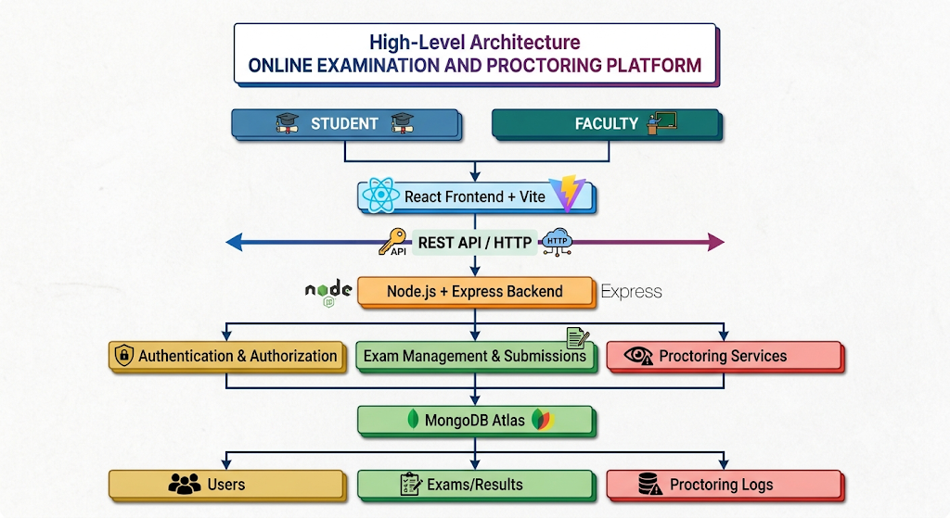

Description of Each Layer (Frontend, Backend, Database)

4.2.1 Frontend Layer
The frontend layer is responsible for providing the user interface and handling user interactions. It is developed using React.js with Vite.
The application provides separate interfaces for students and faculty. Students can register and log in, view available examinations, attend examinations, submit answers, and view their results. Faculty members can create examinations, manage questions, schedule examinations, and view student results.
The frontend also handles the examination timer and browser-based proctoring activities. Browser APIs are used for monitoring full-screen and tab/window visibility changes. Camera access is used for examination monitoring, while TensorFlow.js and the COCO-SSD model support object detection.
The frontend communicates with the backend using HTTP requests and receives data from the REST APIs.

4.2.2 Backend Layer
The backend layer contains the main application logic and is developed using Node.js and Express.js.
It provides REST API endpoints for different modules of the system, including:
- User registration and login
- Authentication and authorization
- Faculty verification
- Examination creation and management
- Question management
- Examination submissions
- Result processing
- Proctoring log management
The backend uses Mongoose to communicate with MongoDB. Passwords are protected using bcryptjs, while JWT is used for authentication and maintaining authorized access to protected resources.
The main backend API groups are:
/api/users
/api/exams
/api/questions
/api/submissions
/api/proctoring
The backend receives requests from the frontend, validates and processes the data, performs the required database operations, and sends an appropriate response back to the frontend.

4.2.3 Database Layer
The database layer is responsible for storing and managing the application's data. The platform uses MongoDB, with the database hosted using MongoDB Atlas.
The database contains information related to:
- User accounts
- Faculty authorization details
- Examinations
- Questions
- Student submissions
- Examination results
- Proctoring events and logs
The major collections used by the system are:
Collection | Purpose
User | Stores student and faculty account information
Faculty | Stores authorized faculty details
Exam | Stores examination details and schedules
Question | Stores questions, options, correct answers, and optional images
Submission | Stores student answers, scores, and submission details
ProctoringLog | Stores examination monitoring events
Mongoose is used as the Object Data Modeling library between the Node.js backend and MongoDB. It provides schemas and models that help the application manage database records in a structured manner.

Deployment Architecture (Cloud, Local, CI/CD Pipelines)

CHAPTER -5 DESIGN

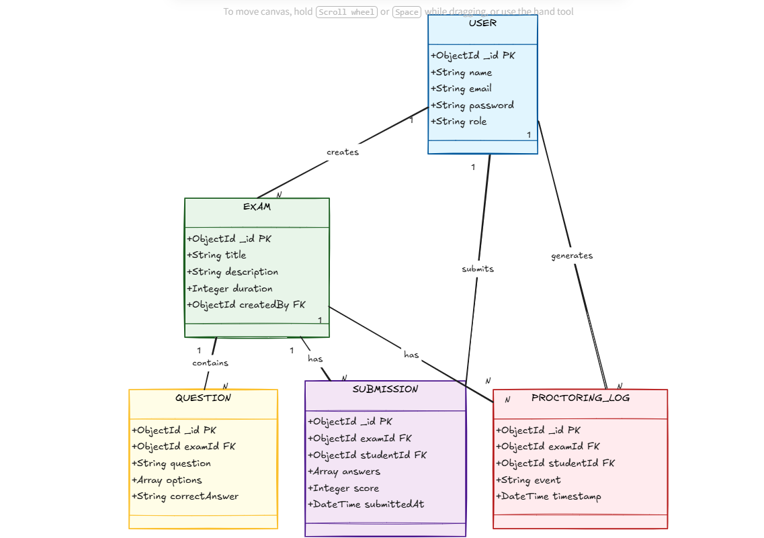

CHAPTER -6 IMPLEMENTATION

6.1 Implementation Overview
The application uses a client-server structure. The frontend is a React application built with Vite. It renders the authentication screens, student examination workflow, and faculty management dashboard. The backend runs on Node.js with Express and exposes API routes for users, examinations, questions, submissions, and proctoring records. Mongoose models connect these operations to MongoDB Atlas.
The implementation separates user interaction from persistent data operations. A student or faculty member uses a screen to initiate an action; the frontend validates and packages the input, then sends an HTTP request. The server checks the request and current user, performs the required operation, and returns a response. The interface then updates its visible state to reflect success, failure, or a pending operation.
The project is divided into frontend and backend folders, as shown in Appendix Figure A4. The frontend source has a top-level App component and reusable components under its components folder. The examination component is kept separate from the top-level authentication and dashboard flow, which makes the exam-specific timer, answers, camera, and proctoring behavior easier to maintain.

6.2 Login and Registration Module
The login screen presents email and password fields and a role selector, as shown in Figure A1. The screenshot shows Student as the default selected role. The page also provides a path to registration. The registration screen in Figure A2 collects a name, email address, password, and role, and provides a return link to login.
In the visible App.jsx implementation (Figure A4), React state holds whether registration is shown, whether a dashboard is displayed, the selected role, login email and password, registration form data, and a user-facing message. Registration state includes name, email, password, and role. State is updated as the user edits the form and is used to submit the selected workflow.
The backend is responsible for validating credentials and creating or authenticating the account. Passwords are hashed with bcryptjs rather than stored in plain text. On successful authentication, JWT is used to identify the user on protected requests. The visible role selector controls the requested user category, while authorization decisions must be enforced by the backend and faculty authorization data.

6.3 Faculty Dashboard and Management Modules
After faculty authentication, the dashboard acts as the main navigation point for administration. Figure A3 shows entry cards for Create Exam, Manage Exams, Questions, Student Results, Proctoring Logs, and Students. Each card describes its purpose and offers an action button, allowing faculty to move directly to a management task.
The Create Exam workflow gathers examination details such as title, description, duration, and schedule. Manage Exams provides access to existing examination records. The question area associates question text, answer choices, correct-answer data, and optional image files with an examination. Results provide a faculty view of student submissions and scores. Proctoring Logs provide access to monitoring events saved during attempts.
Separating these tasks on the dashboard reduces the number of unrelated controls on a single page. Each operation is still checked by the backend. A user should not gain faculty capability only by selecting a role in a form or by reaching a frontend dashboard; the server must confirm the authenticated user and required authorization before it changes examination data.

6.4 Student Examination Module
The examination component maintains state for the loaded questions, current question index, selected answer, collection of answers, time remaining, loading state, user-facing message, submission state, and score. This separation is visible in the AttendExam.jsx code shown in Figure A5. The timer is initialized from the examination duration, with a 60-minute fallback in the displayed code when no duration value is supplied.
Question navigation displays one question at a time and tracks the student’s selections. The saved answer state is used when the student moves between questions so that a previously selected option can be shown again. Loading and message states give the interface a way to indicate that data is being retrieved or that an action needs the student’s attention.
At submission, the frontend sends the attempt data to the backend. The backend compares objective answers with the stored correct answers, computes the score, and persists the submission. The student-facing score is displayed only after the response has been received. Server-side checks should prevent an attempt from being accepted for an unrelated examination or from being recorded more than once where duplicate submissions are not allowed.

6.5 API Integration and Data Flow
Axios is used by the frontend to communicate with the backend REST API. The API groups documented for the application are /api/users, /api/exams, /api/questions, /api/submissions, and /api/proctoring. The resource-based groups make it clearer which part of the application owns a request and provide a consistent boundary between screens and database operations.
For a typical examination attempt, the client first retrieves the examination and question data. The student’s answer changes update local component state. When the attempt is submitted, the client sends the selected answers and relevant examination identifier. The server validates the authenticated user, calculates the objective score, and saves the result. A later result request reads the stored record instead of relying on temporary browser state.
Mongoose schemas describe the records stored in MongoDB. The documented entities include User, Faculty, Exam, Question, Submission, and ProctoringLog. References between these records allow examination questions, student submissions, and monitoring events to be associated with the correct examination and account.
API group | Main responsibility
/api/users | Register and authenticate users and manage user-related operations.
/api/exams | Create, retrieve, and manage examination records.
/api/questions | Add and manage examination questions and related content.
/api/submissions | Receive answers, calculate objective scores, and expose result records.
/api/proctoring | Store and retrieve monitoring events associated with an examination attempt.

6.6 Authentication, Authorization, and Security
Authentication establishes which account is making a request. Registration and login data are sent to the backend for validation. Password hashes are maintained using bcryptjs, and JWT tokens support authenticated API access. Protected routes verify the token before returning user-specific data or changing records.
Authorization determines what an authenticated user may do. Student access covers examinations available to that student, attempts, submissions, and released results. Faculty access includes creating examinations, managing questions, reviewing results, and inspecting proctoring logs. The user interface can hide controls that do not apply to a role, but this is a usability measure only; access must also be checked by backend middleware or route logic.
Environment-specific credentials such as the MongoDB connection string and JWT secret should be supplied through backend configuration and excluded from committed source. CORS should allow the frontend origin used by the selected environment. Production deployments should use HTTPS, restrict database access, and avoid returning stack traces, tokens, password hashes, or sensitive database details in client-visible error messages.

6.7 Browser-Based Proctoring Implementation
The AttendExam component imports TensorFlow.js and the COCO-SSD object-detection model. The browser requests camera access and maintains camera state, including whether the camera has started, whether an error occurred, and whether the camera is unavailable. These states allow the examination interface to reflect camera readiness and handle permission or device problems.
The component also watches for full-screen changes. Figure A6 shows a handler that checks whether the document has left full-screen mode, avoids recording the event while the application is submitting, applies a short interval guard, and records the event with the message “Exited fullscreen mode.” This produces a timestamped monitoring signal that can be sent to the proctoring API.
Other browser visibility events and object-detection results can be represented as proctoring events and stored in ProctoringLog records. Model results depend on the video frame, lighting, camera position, and the browser’s ability to run inference. Thesystem should retain event context for faculty review and should not present an individual model prediction as conclusive evidence.

CHAPTER -7 FEATURES

7.1 Account Access for Students and Faculty
The login screen provides a familiar account entry point with email, password, and a role choice (Figure A1). A student can proceed directly to registration if an account has not yet been created. The registration screen requests the user’s name, email, password, and account type (Figure A2). The form layout keeps the identity and account fields together and links back to login for returning users.
The role-aware interface directs an authenticated student or faculty member to the appropriate workflow. Faculty authorization is checked against faculty records, as described in the earlier system chapters. Account validation and authorization remain separate: a successful login confirms identity, while a faculty authorization check determines whether faculty operations are permitted.

7.2 Faculty Examination Administration
The faculty dashboard groups the major administration tasks into clear entry points (Figure A3). Create Exam starts a new examination record. Manage Exams opens existing examinations. Questions provides question maintenance. Student Results opens score and submission information. Proctoring Logs and Students provide additional monitoring and account views.
An examination record stores its identifying information and scheduling details, including duration and start time. Keeping that information in the database allows the frontend to show the correct availability to students and provides the backend with data to validate submissions. Faculty should review the examination configuration before making it available so that its timing, question set, and access are correct.

7.3 Question Management and Image Support
Faculty can create questions and associate them with an examination. A question may include answer options, the correct answer used for objective evaluation, and an optional image. The question API and Mongoose data model provide the storage path for question records, while the frontend form supports authoring and editing.
Question images are useful for diagrams and other visual prompts. The application supports optional image upload handling through its file-handling layer. Faculty should check that an uploaded image is readable, belongs to the correct question, and does not reveal answer information. When questions are edited, the correct-answer data must remain aligned with the displayed choices.

7.4 Timed Examination Attempt
The student examination screen tracks the loaded question list, current question, selected answers, time remaining, and submission state. The timer is initialized from the exam duration, with the code shown in Figure A5 using a 60-minute fallback when a duration is absent. The student can work through the examination while the component keeps answers and progress in its state.
The countdown supports time awareness, but it is not by itself a security boundary. Browser code can be interrupted or manipulated. The backend should validate the attempt against the examination schedule and submission state and should use server-side timing or recorded timestamps where the project’s rules require enforcement. After a completed submission, the interface displays the returned score or appropriate status.

7.5 Automatic Objective Evaluation and Results
The backend evaluates supported objective questions by comparing submitted answers with the correct answers saved with each question. It calculates the score and stores it with the submission. Storing the result makes it available after the browser session ends and allows faculty to review the score with the associated examination record.
Students can see their results through the student workflow when the results are available. Faculty can review scores and submissions from the Student Results section of the dashboard. The system’s documented automatic evaluation applies to objective questions; descriptive responses would require a separate review or grading workflow.

7.6 Proctoring Support
The platform combines browser activity monitoring with camera-based object detection. It can log tab or window visibility changes and full-screen exits, and the camera workflow uses TensorFlow.js with COCO-SSD to identify configured categories such as no person, multiple persons, or a mobile phone. The visible full-screen handler and event message appear in Figure A6.
Events are stored so faculty can review them from the Proctoring Logs area. Each record is most useful when associated with the student, examination, and event time. Camera permission and a compatible browser are required. If camera access is denied or unavailable, the monitoring feature is limited and the interface should make that status clear.

7.7 Examination History and Record Keeping
The platform maintains the examination, question, submission, score, and proctoring data needed for the student and faculty workflows. Students can consult their examination results and history. Faculty can review completed attempts and monitoring information. The centralized record structure reduces dependence on separate spreadsheets or manually collected answer sheets.
Access to history and results must be scoped to the correct user and faculty role. A student must not be able to retrieve another student’s private submission by changing a request identifier. These ownership checks belong on the backend and should be included in API validation.

CHAPTER -8 TESTING

8.1 Testing Objectives and Method
Testing evaluates whether each role can complete its intended workflow and whether the frontend, backend, and database exchange consistent information. The checks should include account validation, faculty authorization, examination creation, question storage, timed attempts, submission and scoring, result access, and proctoring event persistence.
The project documentation identifies Postman for API testing and browser-based checks for the React interface. Testing can be organized into unit-level checks for validation and scoring logic, API checks for route behavior, integration checks across MongoDB and the backend, and end-to-end checks through a browser. The screenshots in Appendix Figures A1–A6 provide reference points for the login, registration, dashboard, and examination/proctoring implementation.
The table below lists reproducible scenarios and expected outcomes. It does not claim that a particular build passed each case. The actual result column is intentionally left for the project team to complete from the run performed on the final build.

8.2 Functional Test Cases
ID | Scenario and action | Expected outcome | Actual result
TC-01 | Register with valid name, email, password, and Student role. | Account is created and the user can sign in. | Record during execution
TC-02 | Submit registration with a missing required value. | Validation prevents an invalid account request. | Record during execution
TC-03 | Log in with valid student credentials. | Authentication succeeds and the student workflow is shown. | Record during execution
TC-04 | Log in with an incorrect password. | Authentication is rejected without exposing account secrets. | Record during execution
TC-05 | Choose Faculty and authenticate as an authorized faculty account. | Faculty dashboard and permitted management actions are available. | Record during execution
TC-06 | Attempt a faculty-only API operation as a student. | Backend denies the request. | Record during execution
TC-07 | Create an examination with title, duration, and schedule. | Examination is stored and appears in faculty management. | Record during execution
TC-08 | Create and edit an examination question. | Question data remains associated with the selected examination. | Record during execution
TC-09 | Attach an optional image to a question. | Image is uploaded or a clear validation error is returned. | Record during execution
TC-10 | Open an available examination as a student. | Questions load and timer reflects the configured duration. | Record during execution
TC-11 | Navigate away from a question and return. | Previously selected answer remains available. | Record during execution
TC-12 | Submit objective answers. | Submission is stored and objective score is calculated. | Record during execution
TC-13 | Open results using the student account. | The user sees only permitted result information. | Record during execution
TC-14 | Open Student Results as faculty. | Faculty can review the relevant submissions and scores. | Record during execution
TC-15 | Exit full-screen mode during a monitored attempt. | A supported event is logged as an exit from full-screen mode. | Record during execution
TC-16 | Switch browser tab or hide the page. | A supported visibility event is recorded for the active attempt. | Record during execution
TC-17 | Deny camera permission or use a device without a camera. | Camera status or error is communicated and the failure is handled. | Record during execution
TC-18 | Start camera monitoring with permission. | Camera initializes and monitoring can proceed. | Record during execution
TC-19 | Send a proctoring event and review Proctoring Logs. | Stored event is associated with the correct attempt and can be reviewed. | Record during execution
TC-20 | Send a malformed request or missing authentication token. | The API rejects the request with a controlled response. | Record during execution

8.3 API Testing with Postman
Postman can exercise the main route groups independently of the React screens. For each endpoint, a request set should include valid data, missing required fields, invalid identifiers, unauthenticated requests, and role mismatches. The response code and body should be checked, and database state should be confirmed for operations that create or update records.
Authentication tests should verify that a token is accepted for an authorized operation and rejected when absent, malformed, or invalid. User and result queries should verify ownership. Examination and question routes should verify that a faculty account cannot modify records outside its allowed scope. Submission routes should verify the relationship between the authenticated student, examination, and submitted answers.
A repeatable Postman collection can store development-only base URLs and sample identifiers as environment variables. Secrets should not be committed with the collection or placed in screenshots. Use non-production accounts and examination data for testing.

8.4 Integration and Data-Persistence Testing
Integration testing follows data across boundaries. A faculty-created examination should be saved and then retrieved through the API. Its questions should load in the student examination view. A submitted attempt should be recorded with the correct student and examination references; the result should be retrievable by permitted users. A proctoring event should appear in the log view after storage.
Database checks should confirm that identifiers and relationships are valid and that updates do not produce duplicate or orphaned records. File handling should confirm that optional question images remain associated with the right question and that invalid file input produces a clear error. Test data should be removed or reset through the normal development procedure when it is no longer needed.

8.5 Browser, Timer, and Proctoring Testing
Browser testing should cover the supported desktop browsers and screen sizes used by the intended users. Confirm that the login and registration forms remain readable, dashboard cards are accessible, and examination questions and timer remain visible. Test keyboard navigation and input validation where applicable.
The countdown should be checked at initialization, during a question change, and during submission. Verify behavior when the page reloads or loses focus, and confirm that the backend applies the intended schedule and submission rules. The frontend countdown is a user-facing aid and must not be the only source used to determine whether an attempt is valid.
Camera and monitoring checks should include permission granted, permission denied, no camera present, camera unavailable, and model initialization delay. Full-screen exit and page visibility events should be checked for duplicate logging and during submission. Object detection should be tested in varied lighting and camera positions and reviewed for false or missed detections.

8.6 Defect Recording and Test Evidence
For each test run, record the build or commit, date, browser, operating system, test account role, input data, expected outcome, observed outcome, and pass/fail status. Defects should include reproduction steps and a screenshot or API response where appropriate. Do not include passwords, live JWT values, database credentials, or personally identifying student data in test evidence.
After correcting a defect, rerun the failing case and the related workflow. For example, a submission change should be checked from question selection through result display; a role check change should be checked against both permitted and denied requests. This regression approach helps confirm that a localized fix has not broken a connected module.

CHAPTER -9 DEPLOYMENT

9.1 Deployment Architecture and Environment
The application consists of a Vite-served React frontend, an Express backend, and a MongoDB Atlas database. During the development session captured in Figure A4, the Vite frontend is shown at http://localhost:5173, the backend is started with node server.js, and the terminal reports that MongoDB connected successfully. This is evidence of a local development setup; the screenshots do not identify a production host or public deployment URL.
For a production deployment, the frontend and backend can be hosted separately or together, provided the frontend can reach the API and the backend can reach MongoDB Atlas. The production frontend API address, backend CORS allowlist, database network access, and secret configuration must all match the selected hosting environment.

9.2 Local Development Setup
Obtain the project repository with both backend and frontend folders. Install the backend dependencies from the backend package manifest and install the frontend dependencies from the frontend package manifest. Use the included lockfiles and the package manager selected by the project so the installed versions remain consistent.
Configure the backend environment values required by its source, including its MongoDB connection string and JWT secret. Start the backend with the command visible in the project terminal, node server.js. In a separate terminal, start the Vite frontend using the development script from the frontend package file; the screenshot shows the resulting local address at port 5173.
Open the frontend address in a browser. Confirm the API base URL points to the running backend and that CORS allows requests from the local Vite origin. The backend terminal should report that it is running and has connected to MongoDB before attempting database-dependent workflows. Exact environment variable names and backend port should be taken from the project configuration rather than assumed.

9.3 Production Configuration
Create a production frontend build using the build script defined in the frontend package file. Vite’s production build produces static assets suitable for a static web host or for serving through a web server. Set the frontend API base URL to the production backend before building, because a development localhost URL cannot serve users outside the developer’s computer.
Deploy the backend to a Node.js-compatible host and configure its runtime command, environment variables, and health behavior according to the hosting provider. Set the allowed frontend origin in CORS. Configure MongoDB Atlas database users and network access for the deployed backend, and store the connection string and JWT secret using the host’s secret configuration facility.
Use HTTPS for both the public site and API. Browser camera access generally requires a secure context, and HTTPS also protects credentials and tokens during transport. Production secrets must not be embedded in the frontend build or placed in source control.

9.4 Database, Files, and Operational Readiness
Before release, verify that the backend connects to the intended MongoDB Atlas database and that required collections and indexes are available. Confirm that database permissions are limited to the application’s needs. Establish a backup and restore procedure and a retention policy for user accounts, submissions, and proctoring records.
If question images are stored outside the database, the deployment must provide persistent file storage and ensure that saved image references remain accessible to the question view. The project documentation identifies Multer for file handling, but the final storage destination should be taken from the actual environment configuration.
Production logging should capture operational errors without logging passwords, tokens, or full private student records. Monitoring should report backend availability, failed database connections, and resource pressure so the team can respond when the service is unavailable.

9.5 Release Verification
After each deployment, verify the login and registration pages, a student account, a faculty account, examination creation, question retrieval, timed attempt, submission scoring, results, and proctoring log persistence. Confirm that a student cannot open faculty-only actions or another student’s result. Check camera permissions over HTTPS and verify that a denied permission does not cause the examination page to fail unexpectedly.
Record the release date, source revision, frontend address, backend address, database environment, and any known limitations in the project’s release notes. The public hosting provider and production URL should be filled in only after an actual deployment has been completed.

CHAPTER -10 CHALLENGES AND LIMITATIONS

10.1 Coordinating Role-Based Workflows
Students use the platform for examinations, submissions, and results, while faculty manage examinations, questions, scores, and proctoring logs. The dashboard and role-specific screens organize these tasks, but the backend must enforce permissions because interface controls alone cannot prevent unauthorized requests.

10.2 Synchronizing Timer, Answers, and Submission
The examination flow must keep the timer, question selection, saved answers, and submission record in sync. Browser timers can be delayed by inactive tabs or device load, so the backend should validate schedules and submission state. The interface should prevent duplicate submissions and explain how to recover from network failures.

10.3 Browser Permissions and Proctoring Variability
Camera access depends on browser permission and device availability, and full-screen or visibility events can vary by browser. Object detection also depends on lighting, camera angle, and device performance, which can lead to missed detections or false alerts. Proctoring events should be treated as review signals, not definitive judgments.

10.4 Data Security and Privacy
The system stores account details, questions, answers, scores, and monitoring events, so access controls and secure configuration are essential. Password hashing, token checks, HTTPS, restricted database access, and protected secrets reduce exposure. Users should be told when camera monitoring is active and what data is retained; shared screenshots and logs should not reveal credentials or student information.

10.5 Current Functional and Operational Limitations
Automatic scoring currently covers objective questions; descriptive answers need a separate grading process. Browser-based proctoring cannot lock down a device, provide continuous human supervision, or guarantee detection. The documentation shows local development but does not establish production deployment, capacity, backups, or CI/CD, so these areas need validation before high-stakes use.

CHAPTER -11 FUTURE ENHANCEMENTS

11.1 Examination and Question Enhancements
The question module could add multiple-select, true/false, short-answer, and descriptive questions, along with a tagged question bank and randomized question and option order. Faculty could also use negative marking, attempt limits, accommodations, scheduled result release, and bulk import or export. A preview would help verify questions, answer keys, timing, and schedules before publishing.

11.2 Student and Faculty Experience
The student interface could add autosave and connection indicators, question navigation, unanswered-question summaries, and a final submission check. Recovery from network interruptions should preserve answers and avoid duplicate submissions. Faculty analytics, downloadable reports, controlled re-evaluation, and optional student feedback could improve review and reporting.

11.3 Proctoring Review and Fairness
A chronological review dashboard could link each event to its timestamp, examination, and submission, with filters and faculty notes. Detection alerts should remain distinct from confirmed policy violations. Model performance should be evaluated across devices and conditions, with clear camera and model readiness status; any added identity or audio monitoring requires careful review of consent, privacy, bias, and accessibility.

11.4 Reliability, Security, and Scale
Future work could add account recovery, multifactor authentication, token revocation, rate limiting, consistent validation, and stronger audit trails. Backups, restore drills, health checks, structured logs, and load testing would improve operations. Indexes, pagination, and aggregation should follow measured bottlenecks, while separate development, staging, and production settings protect student data and secrets.

CHAPTER -12 CONCLUSION

12.1 Summary of the Completed Platform
The Online Examination and Proctoring Platform brings examination administration, student attempts, automatic objective evaluation, and basic remote monitoring into a single web application. Students can register or sign in, access available examinations, answer questions within a timed session, submit answers, and view results. Faculty can create and manage examinations, maintain questions, review student scores, and inspect proctoring logs.
The screenshots document important parts of the completed interface and implementation. Figures A1 and A2 show the login and registration forms. Figure A3 shows the faculty dashboard and its management areas. Figure A4 shows the project layout and a local development run with the Vite frontend and backend connected to MongoDB. Figures A5 and A6 show the examination state and full-screen exit monitoring logic.

12.2 Technical Achievement and Learning
The project combines React component development and state management with REST API communication, Express route organization, Mongoose data persistence, password hashing, JWT authentication, role-based access, and browser APIs. It also integrates TensorFlow.js and COCO-SSD for in-browser object detection and handles event records for examination review.
The development process provides practical experience in connecting user-facing workflows with backend validation and persistent records. It demonstrates the importance of separating authentication from authorization, treating the server as the authority for submissions, and handling browser permissions and network failures explicitly. The team also gains experience in organizing a full-stack repository and running frontend and backend services during development.

12.3 Project Outcome and Scope
The completed system provides a working foundation for online examination management and supports basic browser-based proctoring. Its usefulness depends on correct deployment configuration, secure data handling, and clear institutional rules for monitoring and review.
The platform is an academic project and should be extended and assessed before use in high-stakes examinations. Automated object detection and browser activity logs can support human review, but they cannot replace a complete invigilation process or independently establish misconduct. Future improvements can strengthen reporting, reliability, accessibility, security, and faculty review tools.

CHAPTER -13 REFERENCES

Technical Documentation
React. Quick Start and React Reference. https://react.dev/learn and https://react.dev/reference/react
Vite. Getting Started and Building for Production. https://vite.dev/guide/ and https://vite.dev/guide/build
Node.js. Node.js Documentation. https://nodejs.org/docs/
Express. Express Documentation. https://expressjs.com/
MongoDB. MongoDB Manual. https://www.mongodb.com/docs/
Mongoose. Mongoose Documentation. https://mongoosejs.com/docs/
TensorFlow.js. TensorFlow.js Guide and Models. https://www.tensorflow.org/js/guide and https://www.tensorflow.org/js/models
MDN Web Docs. MediaDevices.getUserMedia(). https://developer.mozilla.org/docs/Web/API/MediaDevices/getUserMedia
MDN Web Docs. Fullscreen API. https://developer.mozilla.org/docs/Web/API/Fullscreen_API
MDN Web Docs. Page Visibility API. https://developer.mozilla.org/docs/Web/API/Page_Visibility_API
JSON Web Token for Node.js. https://github.com/auth0/node-jsonwebtoken
bcryptjs documentation. https://github.com/dcodeIO/bcrypt.js
Axios documentation. https://axios-http.com/docs/intro

Project-Specific Sources
Application source files visible in the supplied project screenshots: frontend/src/App.jsx and frontend/src/components/AttendExam.jsx. Project structure and local run state are illustrated in Appendix Figure A4.

CHAPTER -14 APPENDICES

14.1 Installation and Setup Guide
Obtain the project source with its backend and frontend folders. Install dependencies separately from the package files and lockfiles in each folder. Configure the backend environment using the names expected by the source code. The configuration must provide the MongoDB connection string, JWT secret, and any allowed frontend origin required by the server.
Start the backend with the project command shown in the supplied terminal screenshot: node server.js. Start the frontend using the development script defined in its package file. The screenshot shows the Vite development server at http://localhost:5173 and a successful MongoDB connection. Use these local addresses only on the development machine; set the actual backend URL and frontend origin for any separate deployment.
For production, create the frontend build using the Vite build command, deploy the backend to a Node.js-compatible host, configure HTTPS and CORS, and allow the backend to connect to MongoDB Atlas. Verify the login, faculty, student, results, and proctoring workflows after deployment. Do not commit live secrets or use real student data in a development environment.

14.2 User Guide
Students open the login page, select the student role, and enter their email and password. A new user can use Register to create an account by providing name, email, password, and role. After sign-in, the student opens an available examination, checks the displayed duration, responds to questions, and submits the attempt. The student can then view released results.
Faculty sign in with an authorized faculty account. The dashboard provides entry points for creating and managing examinations, managing questions, viewing student results, reviewing proctoring logs, and viewing students. Faculty should verify the schedule, duration, question content, and answer key before making an examination available. After the examination, faculty can inspect submitted scores and monitoring records.

14.3 Screenshot Notes
The figures below are supplied screenshots of the project interface and source code. They document the visible login and registration forms, faculty dashboard, local development environment, examination component state, and full-screen event handler. The source-code screenshots are implementation evidence and are not a substitute for the complete source repository.

14.4 Project Screenshots
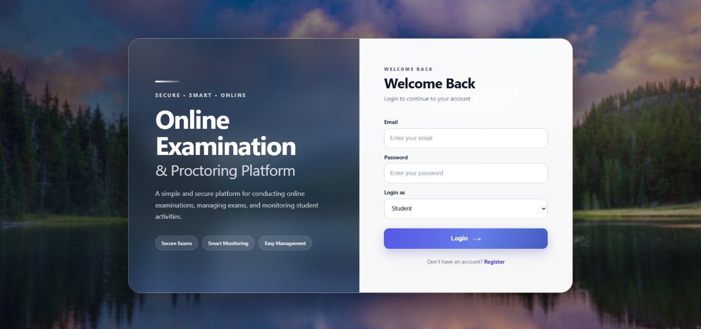
Figure A1. Login screen with email, password, and role selection.

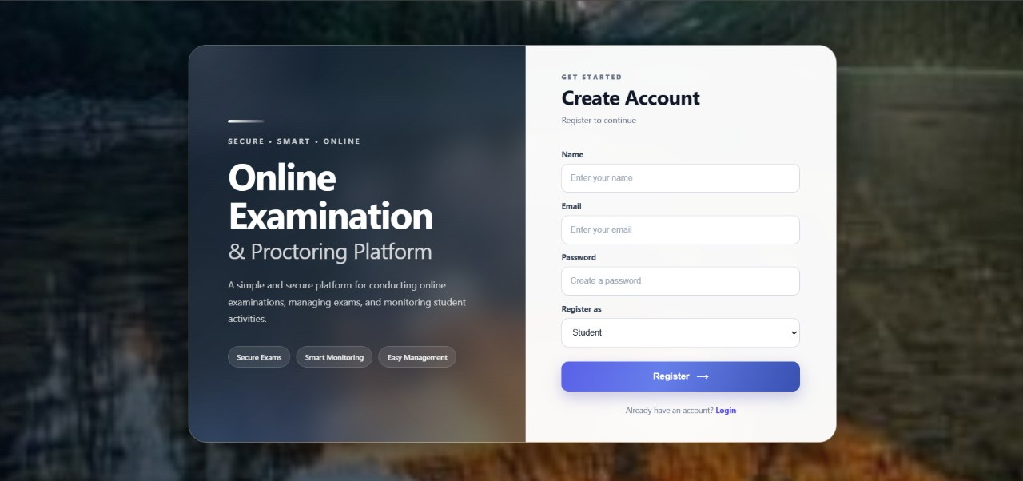
Figure A2. Registration screen with name, email, password, and role fields.

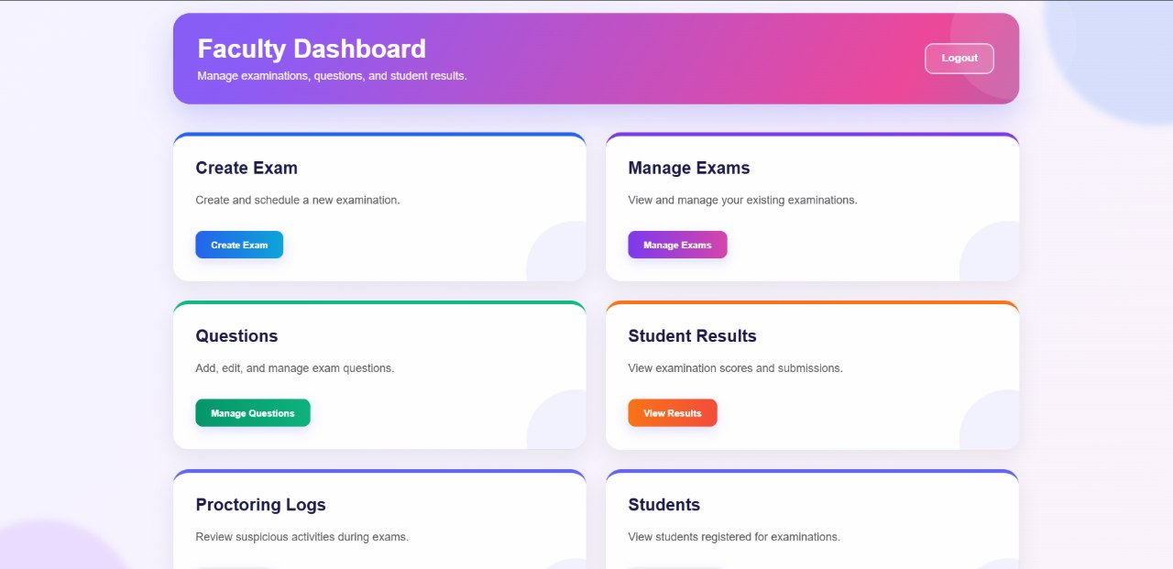

Figure A3. Faculty dashboard with examination, question, result, proctoring, and student areas.

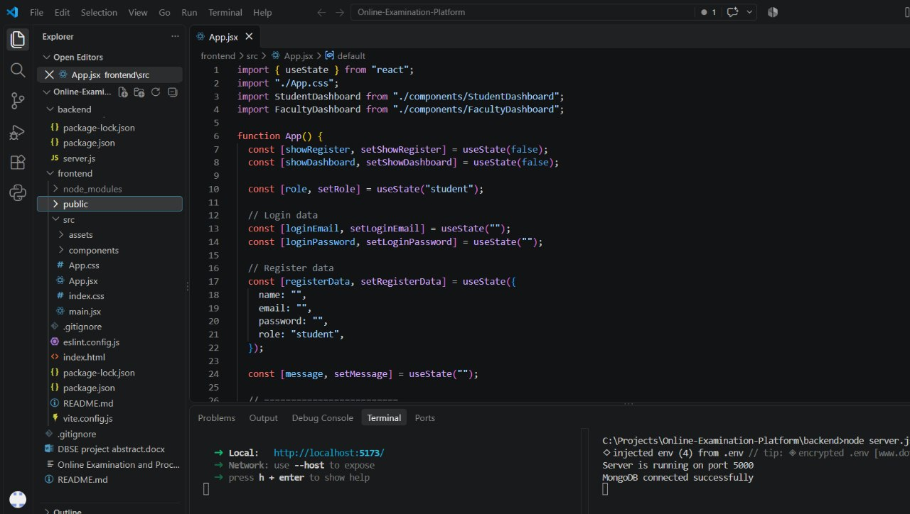
Figure A4. VS Code project structure and local frontend/backend execution with MongoDB connected.

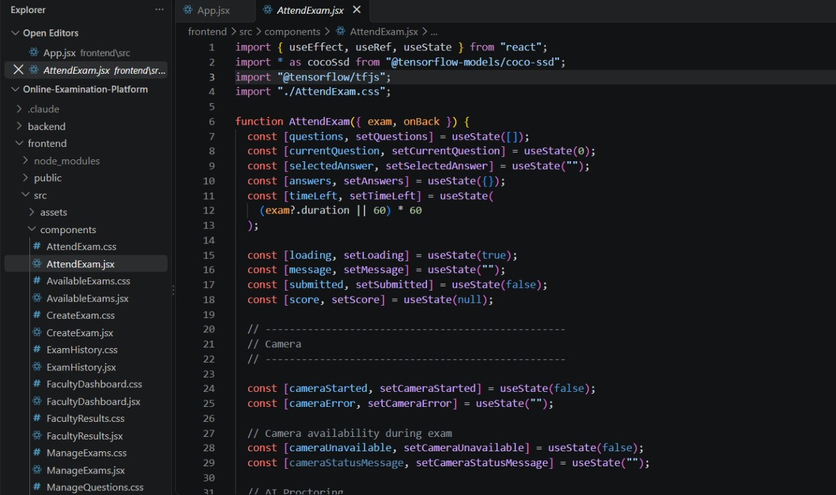
Figure A5. Attend Exam component imports and state for questions, answers, timer, camera, and submission.
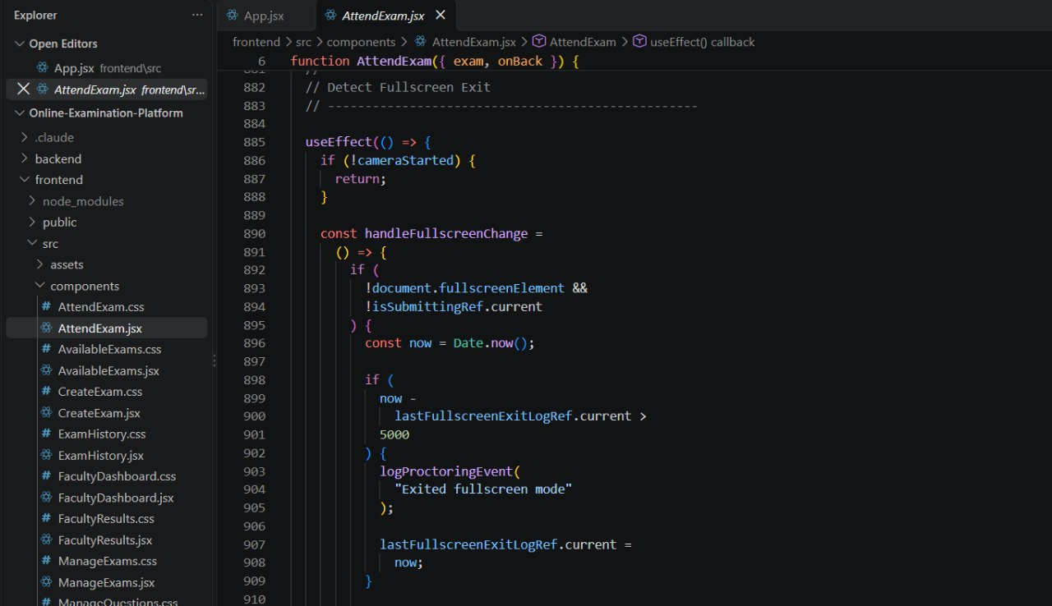

Figure A6. Full-screen change handler logging an exit event during an examination.

